Predicting the best place to life in in Germany to **make** an AI career

David Galve Masip

May 4, 2020

1. Introduction
   1. Background

The explosion of AI (Artificial Intelligence), DS (Data Science) and DM (Data Mining) has a huge impact in the markets. There is more and more people likely to find out in which cities those companies are arising and clustering to find out where is a suitable place to life in which satisfies those features and where would be easy to start with such a professional career like this. And what could be more elementary than “*where I am*”? For example, it could be interesting to life in Berlin where I know that there are a huge amount of yearly conferences, related meetings, etc. even plenty of casual meetings in coffee-shops were people with the same interests share new ideas. Nevertheless would be not a good idea (still) to move to Lübeck, city in which there is only one enterprise related with AI (at May 4, 2020)!

1.2. Problem

Searching for information is now a days very easy though quite difficult to trust and most of the times the user needs to double-check if the response one get from a job-finder from the internet really meet her/his expectations and needs. This leads to a tedious parallel search on the internet which can be really hard to determine if a concrete enterprise is far away from being close to a DS cluster or not. This project aims to predict easily which city is the more appropriated to life in for such a need and compare it easily with e.g. data queried from job-finder platforms, i.e. LinkedIn, StepStone, etc.

1.3. Interest

Everyone starting/continuing but moving a career based on AI, DS or DM and thinking about not to transfer a lot.

1. Data acquisition and cleaning
   1. Data Sources

Search locations are get from Python’s [Geopy](https://geopy.readthedocs.io/en/stable/) package, most crowded cities in Germany from the [Wikipedia](https://en.wikipedia.org/wiki/List_of_cities_in_Germany_by_population) and the main data for obtaining the enterprise locations from [FourSquare](https://developer.foursquare.com/docs/places-api/).

* 1. Data cleaning
     1. Function *get_df*

The data is first queried and transformed to json data for later normalize it in a Pandas’ data frame.

* + 1. Function filter_df

Then these Pandas’ data is filtered for company’s name, categories and location, rest is dropped.

* + 1. Function get_category_type

This last filter appends all sub-columns in columns for categories. This allows the developer to easily work with the data in that final Pandas’ data frame.

1. Data exploration
   1. Clustering

I found out that categories can be clustered to determine which kind of branch ones prefers the most, i.e. investigation, offices, teaching, etc. For this it is used several queries in FourSquare which these filters and then those data frames are joined in one and clustered. This clusters are set up in a folium class and plotted showing per state (Bundesland) a choropleth.

Choropleth for number of businesses in Germany related with DS:

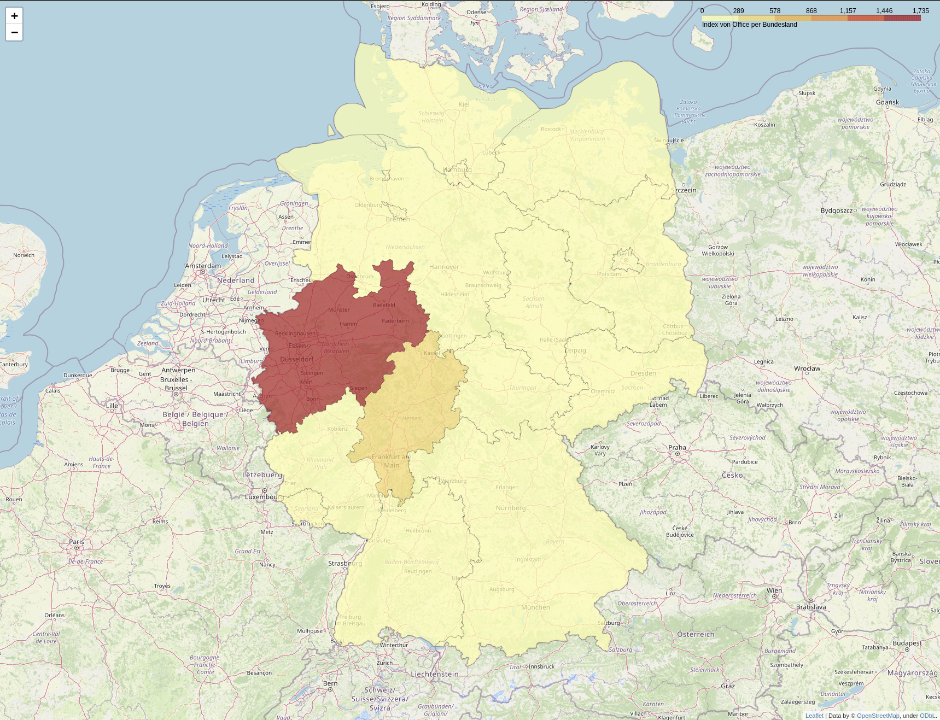

Choropleth for number of education centres in Germany related with DS:

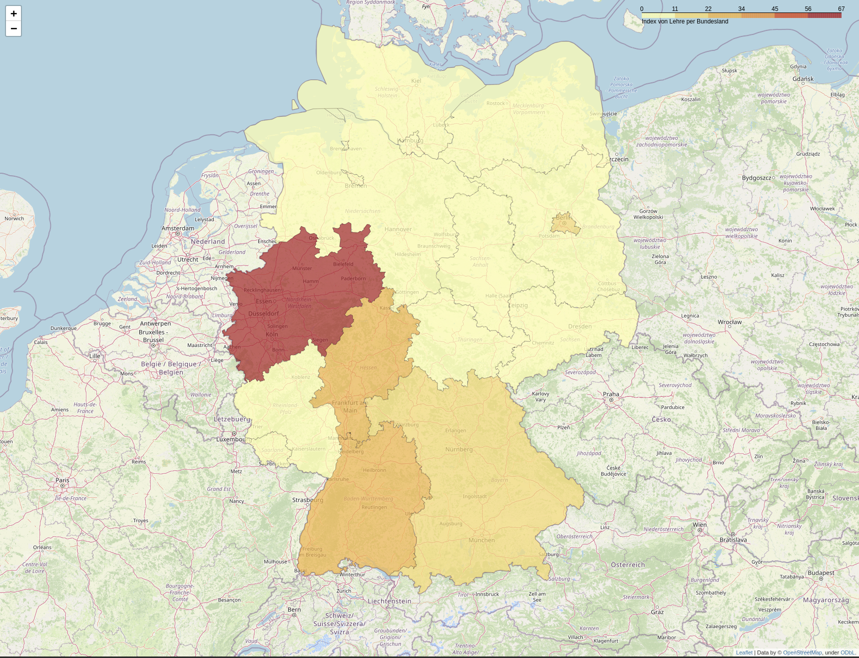

* 1. Relationship between states

Following will be shown a relationship between the actual number of businesses related with DS and education centres related with DS:

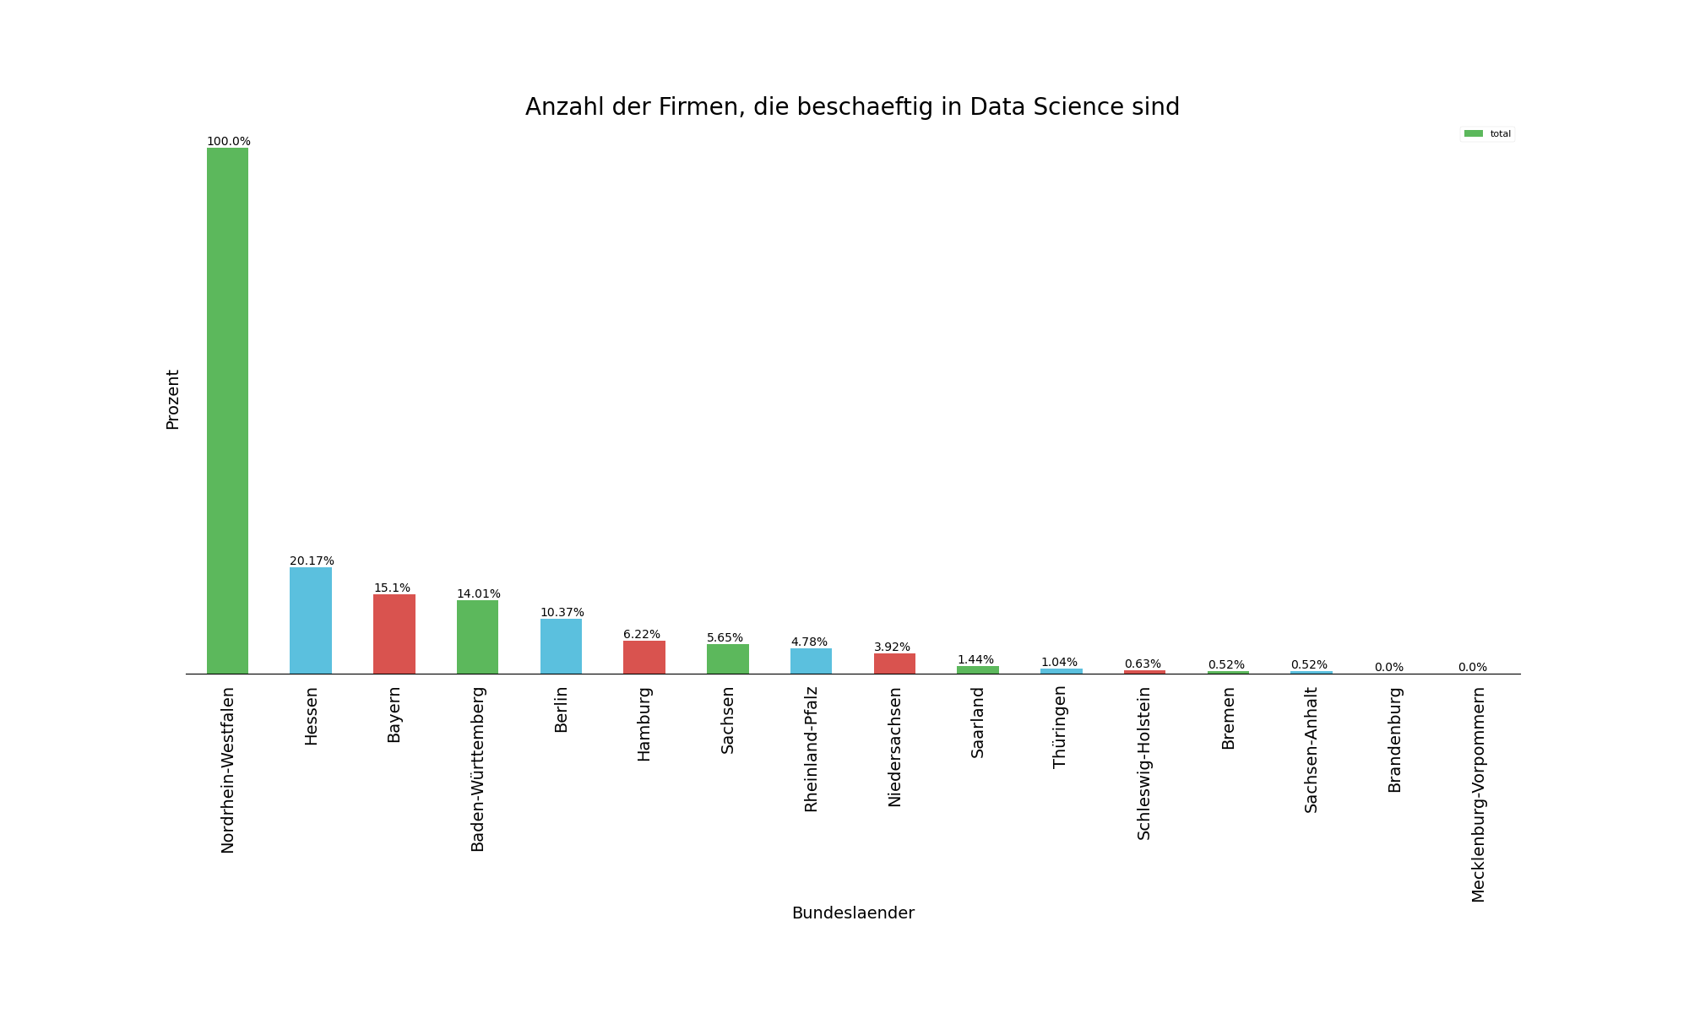and for education centres:

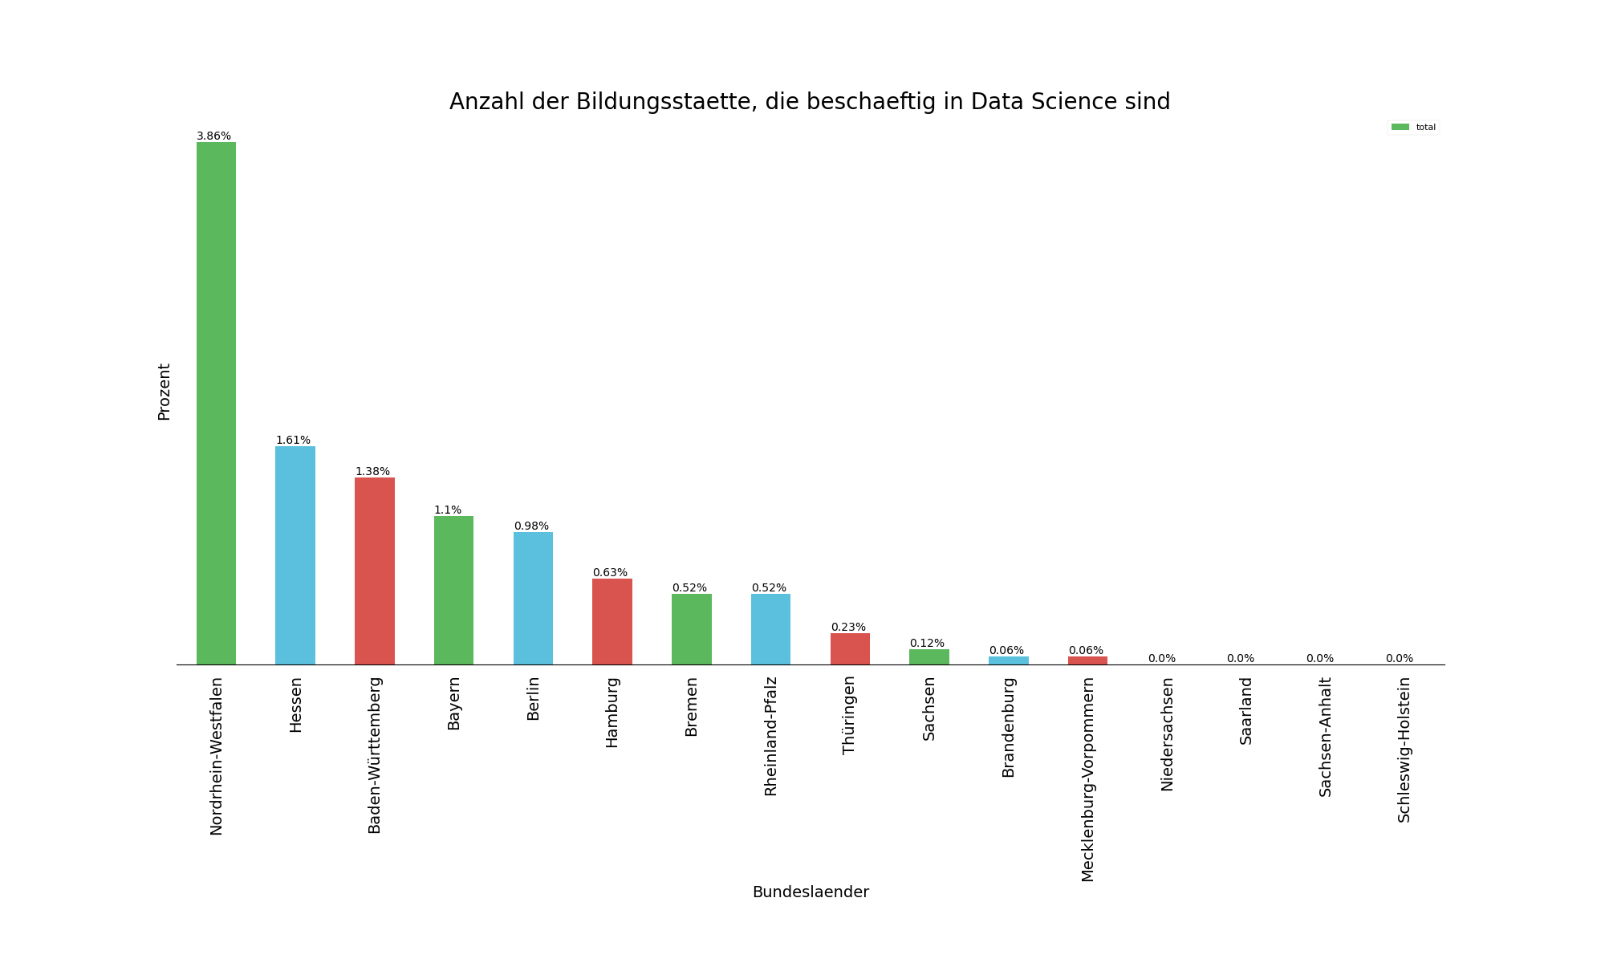

1. Conclusions

The conclusion is that the most likely state in Germany for starting a career/ continue a career in DS is the west, and concrete in Nordrhein-Westfalen where the whole amount of businesses and education centres are.

1. Further analysis

Further studies can be made and they are under development. These will be now enumerated:

1- It can be developed a progression on the time regards of the version date from which the Foursquare API’s call is made. With it, it is possible to predict where these clusters will move

2- This approaches can be made with research in data sources like rent-flat prices, etc.